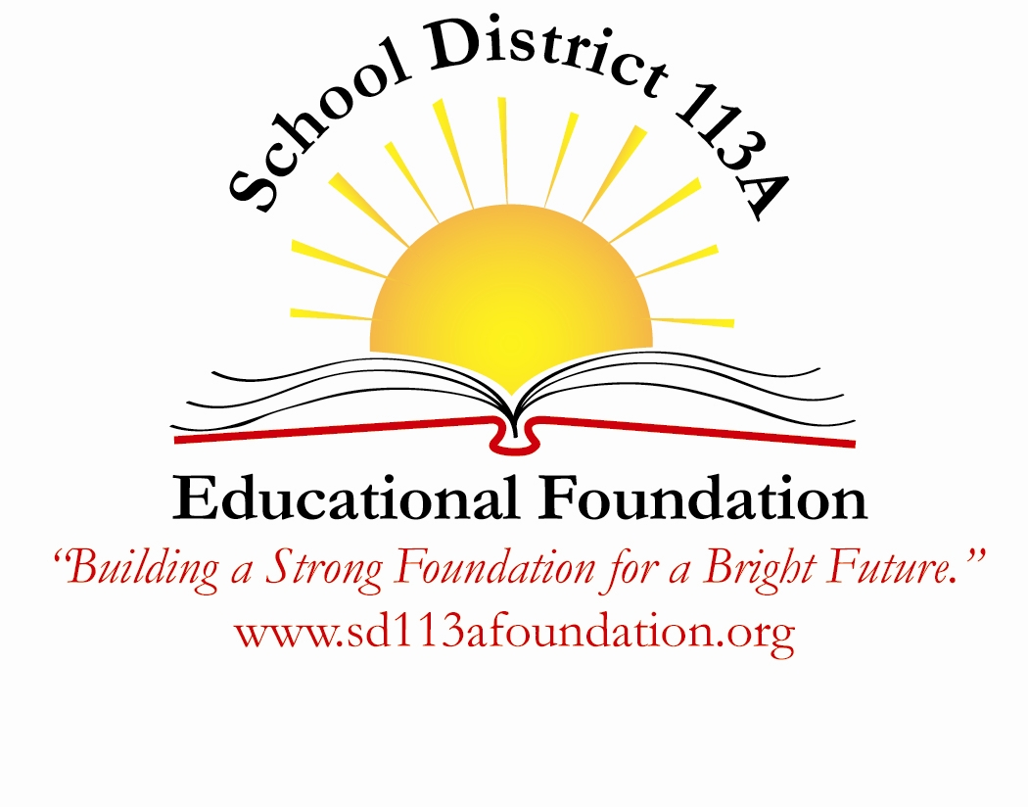
School District 113A Educational Foundation
Request for Alternative Funding
Use this form to initiate the application process to grants offered by other businesses or foundations.

Applicant Information
Name: _____________________ Email: ___________________
School: ________________ Grade: ______________
Home phone: __________ Cell phone: ____________
Applicant is: (check one)
Teacher Administrator District 113A staff member

Summary of Request
Describe the program or materials for which you are requesting funding. Explain how that will align with the Common Core standards and current curriculum.

Grant Information
If interested in a specific grant, please include that here with the appropriate website and grant application deadline. (note: this form must be submitted 30 days before the grant deadline)

Timetable for Proposal
Give start and completion dates if applicable. Is this a one-time program or a potential multi-year program?

Evaluation
Describe how you will determine whether your program is successful. What will be the ongoing benefits of the program to the district? What are the measurable results expected? How many students will benefit from the program?

Budget
Please provide an itemized budget of estimated costs including expected further costs to maintain the program. Include material costs, registration fees, and technology fees.
Expenses | Anticipated Cost $$
Instructional materials | $
Technology needs | $
Consultant fees | $
Cost to maintain program | $
Other | $
Total grant request | $

Is this grant request part of a more comprehensive program?

Is funding being sought or provided by any other sources?

Technology Approval: (approval from technology director necessary if grant request is related to technology needs -computer software programs, computers, iPads, etc.)
I have read this application and agree that the district’s technology committee can support this proposal.

Name: _______________________________ Date:_____________________

Statement from Principal
I have read this application and I fully support this proposal. I certify that funding for this project is not available within the District’s operating budget.

Name: ________________________________ Date: __________________

