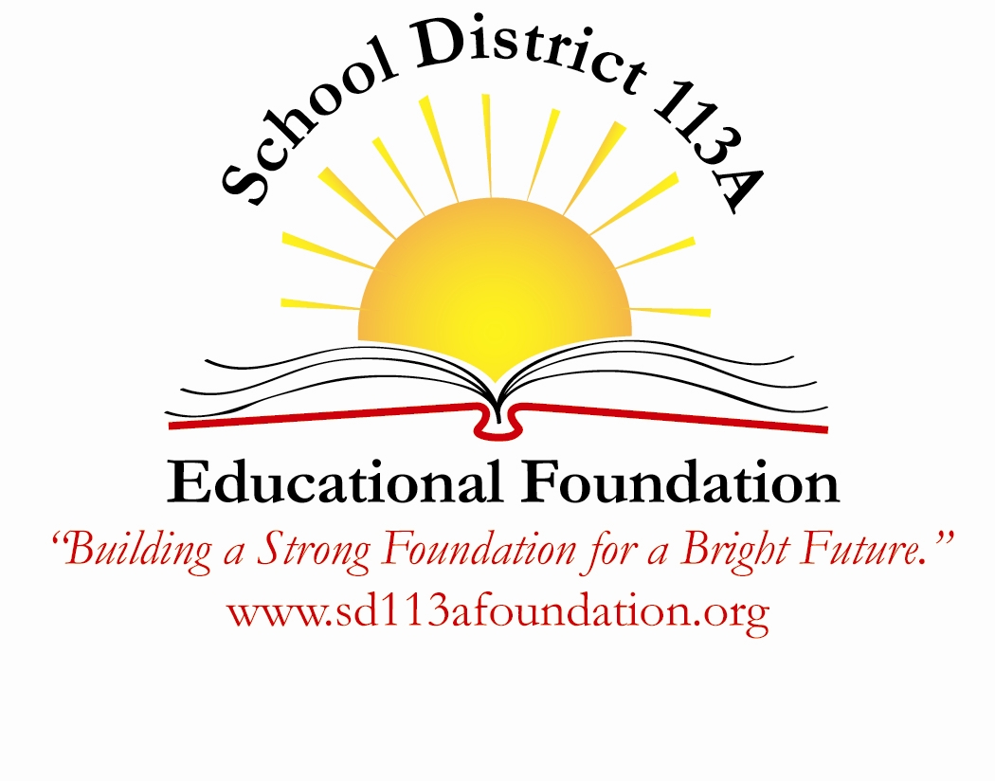
Become a Friend of 113A

Your donation delivers materials and programs for your community’s classrooms!

We believe our schools should be more than adequate. We believe our students deserve access to a superior education. If you support those goals, consider donating today, so we can ensure a bright future for our students and our community.

Since 2010 the Foundation has funded more than $120,000 in grants to teachers across the district. We have provided dynamic instructional tools such as iPads, Mimio Teach Systems, MP3 players and microscopes. We have supported innovative teaching techniques by funding programs like the JASON Project, Nature Mapping and math learning games. We have provided students with access to educational software including BrainPop and BookFlix. And we have filled classrooms with new materials to help learners across all abilities stay ahead of the curve.

Our mission is to:
- seek and provide financial and other resources to support education, innovation and enrichment in pursuit of academic excellence for the SD113A community.
- provide a charitable vehicle through which individuals, businesses and corporations may make financial contributions and endowments.
- provide funds beyond the normal operating budget of SD113A for specific educational programs and activities for students and staff.

The SD113A Educational Foundation is a 501(c)(3) charitable organization committed to improving academic outcomes for all students in the district. We collaborate with the board of education, school administration, staff members and other community organizations to make a difference for our students.

Better Lawns & Gardens supports the SD113A Educational Foundation
For every 50 contributions of $113, Better Lawns & Gardens will donate a planting for the school district. To date, they have donated and planted 4 trees.

Help us grow and cultivate the future of the students of SD113A!

